**2 Vermont Standard Offer Program Plants Commissioned**

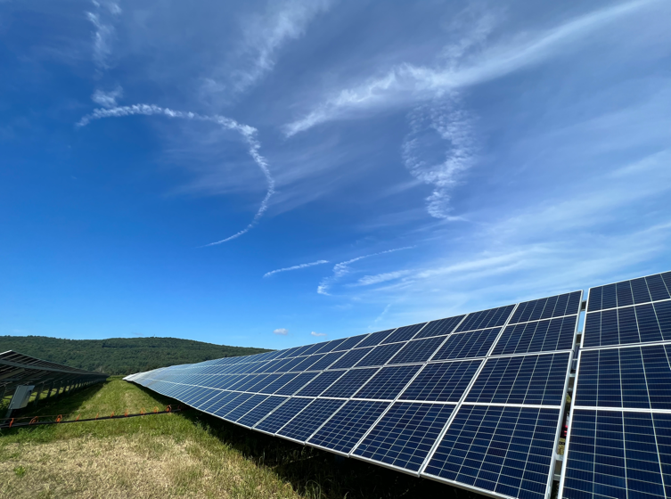News Release — VEPP Inc.

63 Acre Solar

September 8, 2023

Clarendon and Rutland, VT – Two Vermont Standard Offer projects, 63 Acre Solar and Gray Solar were successfully commissioned this summer in Green Mountain Power Corporation service territory. 63 Acre Solar is located in Clarendon with a capacity of 2.2 MW AC (3.3 MW DC). The new solar photovoltaic array was built using Canadian Solar manufactured 395-watt modules and 20 Chint inverters on a 13.5 acre parcel. Gray Solar is located nearby in Rutland. The plant was built with 16 Siemens inverters using Trina and Hanwha modules comprising a total of 6,210 modules with a 2.2 MW AC capacity.

The Standard Offer Program was established in 2009, pursuant to 30 V.S.A. § 8005a, in order to promote the rapid deployment of small renewable generation through long-term contracts. The total program capacity of 127.5 MW was distributed annually by a least-cost auction RFP that included capacity carve-outs for wind, food waste, hydroelectric, and biomass.

For more information about the Standard Offer Program, visit [www.vermontstandardoffer.com](http://www.vermontstandardoffer.com) or email meghan@veppi.org.